**TASK-06**

**Third party API**

Firstly we need to create the components that are need for the fetch api and connect in sites.js and provide necessary properties to it and also number of cards needed to provide with properties

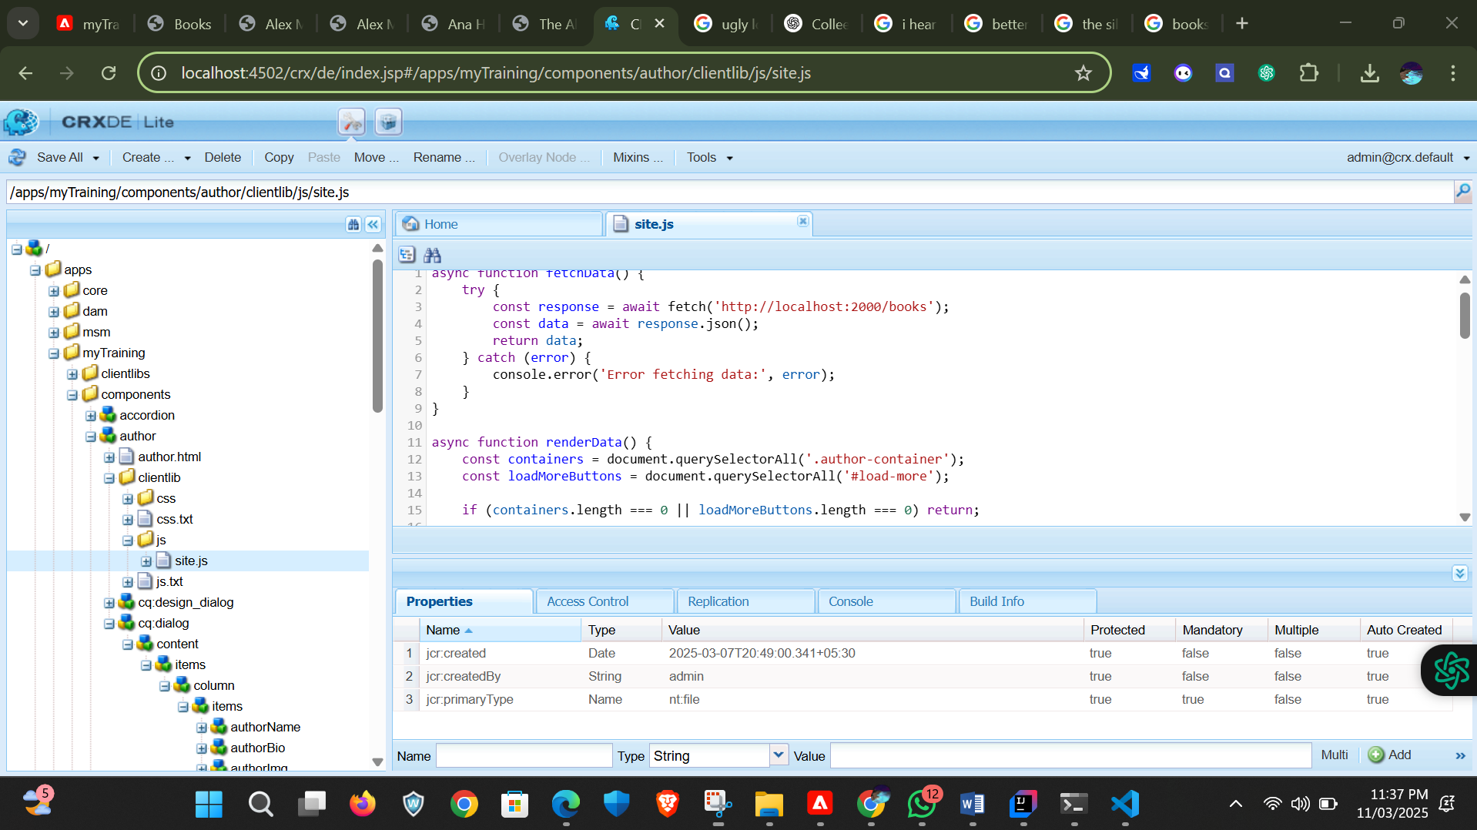

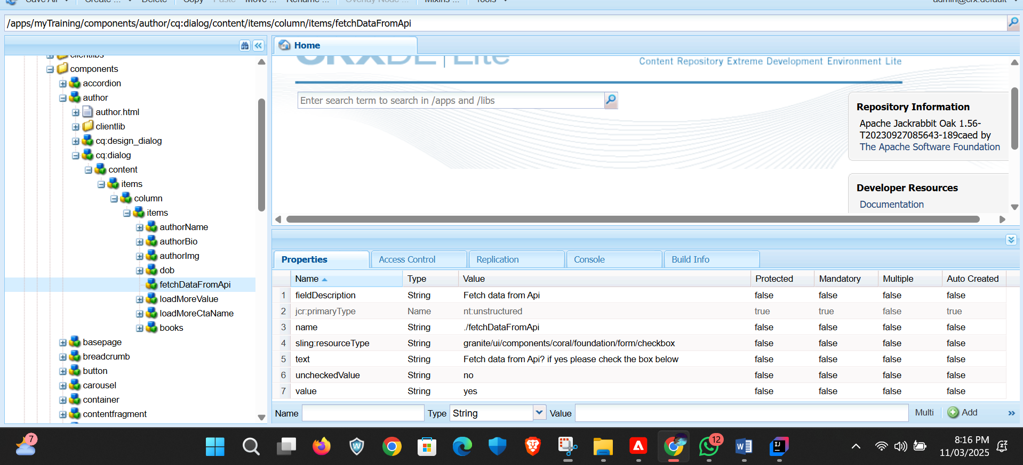

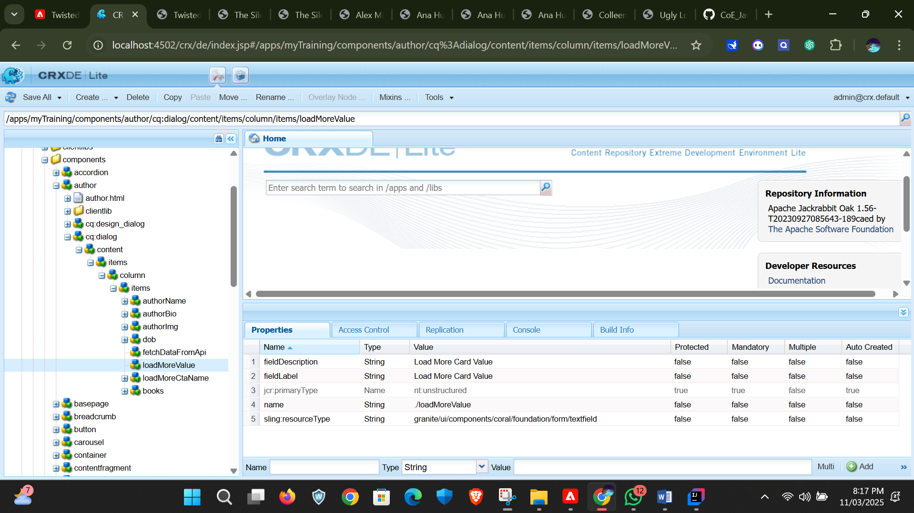

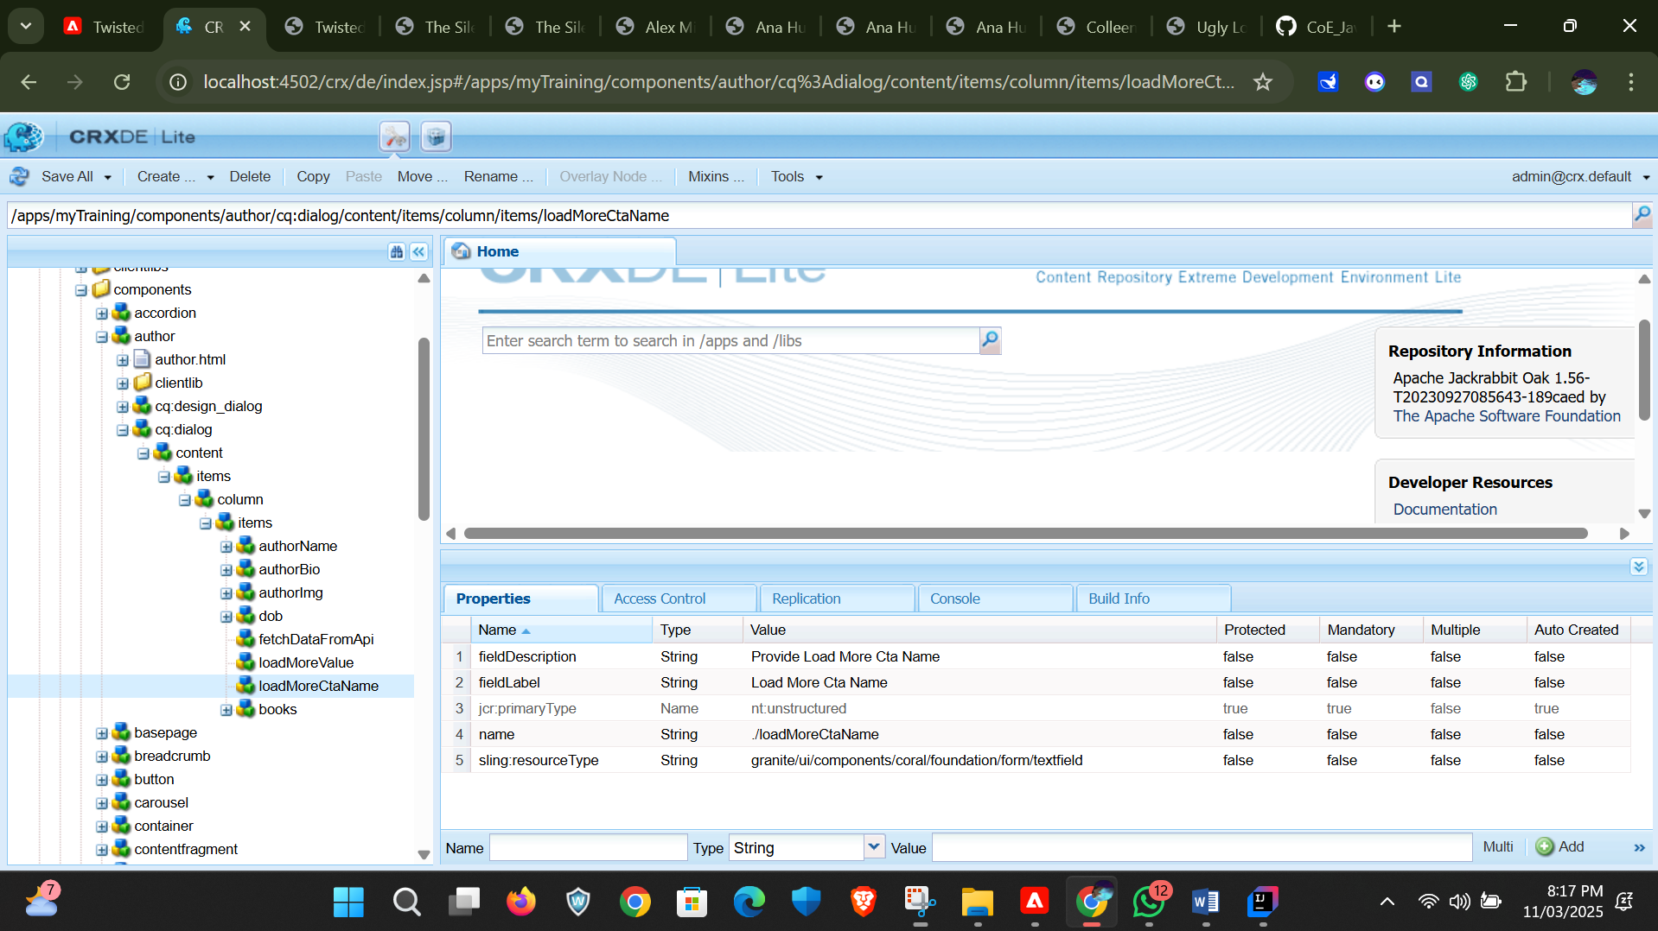

In author model we need to import the components we created with initization fetch api()

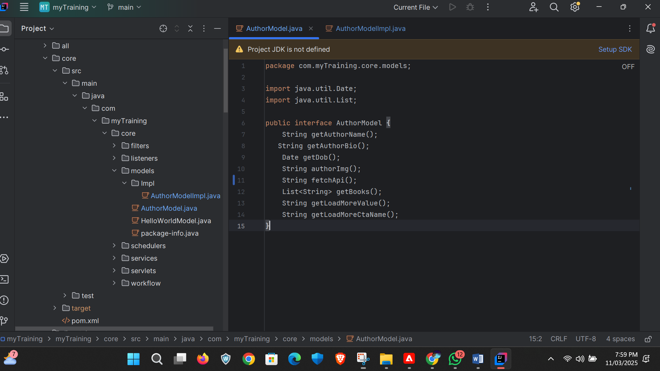

In authorModelImp.java we need to override fetchapi we were initialized in order to return the api in the card value.

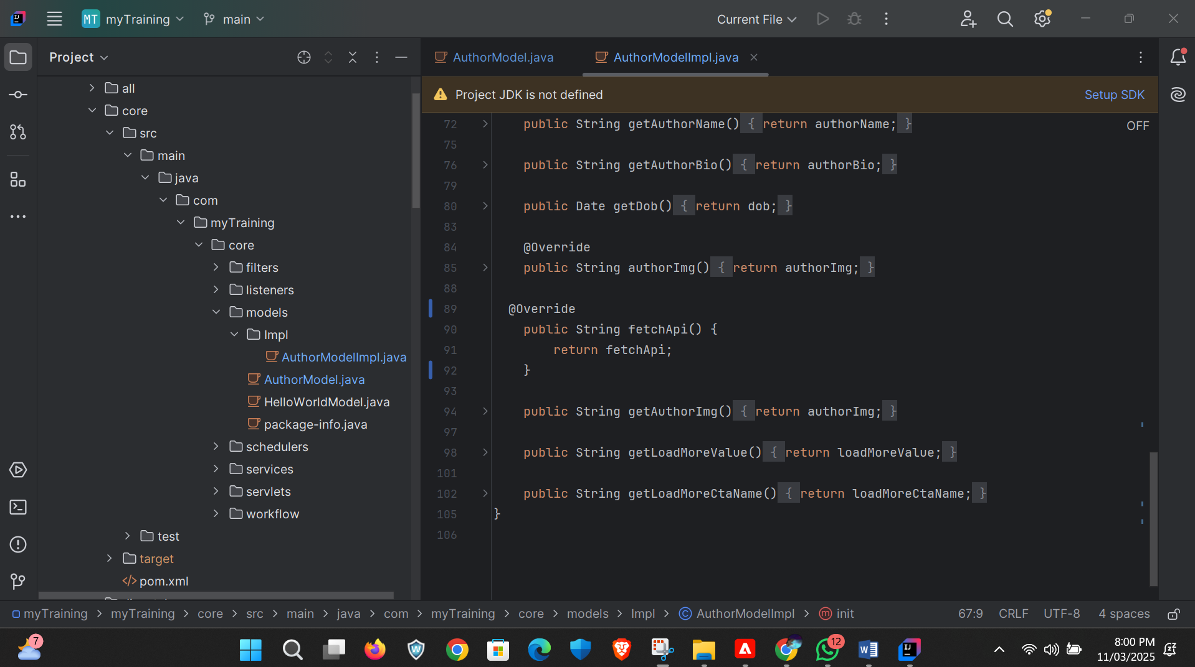

After that we need to create author detail template

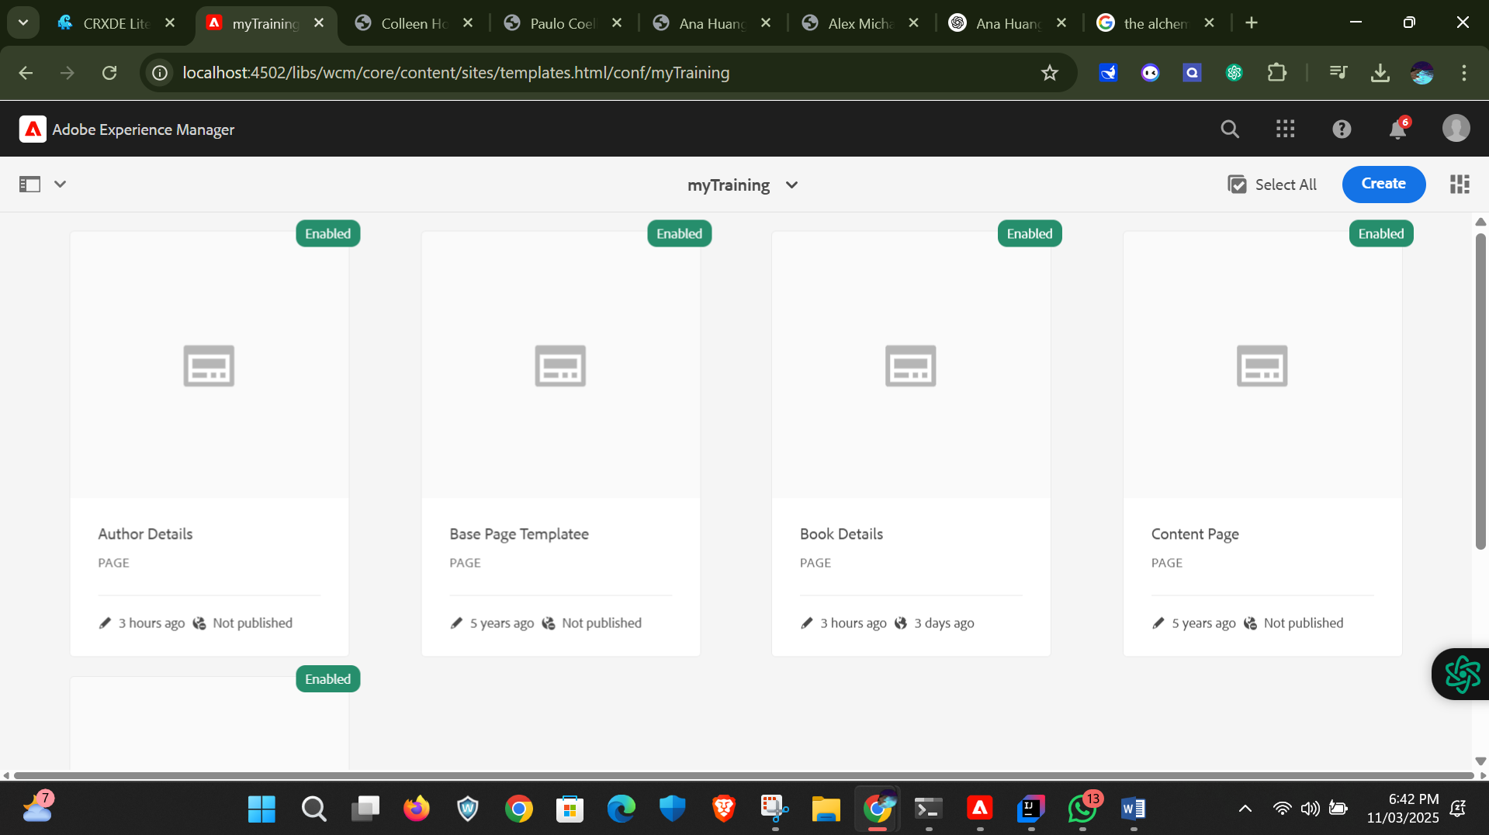

After creation of template we need to create page for author

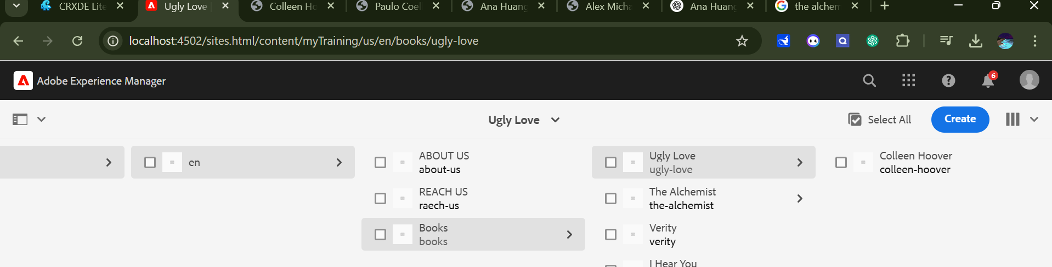

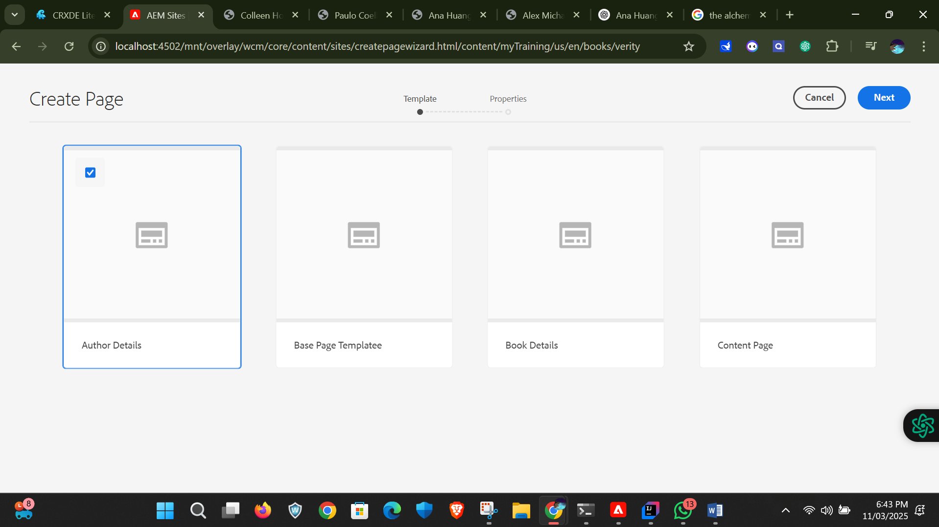

After creating author page we need to drag and drop the author component and configure it.

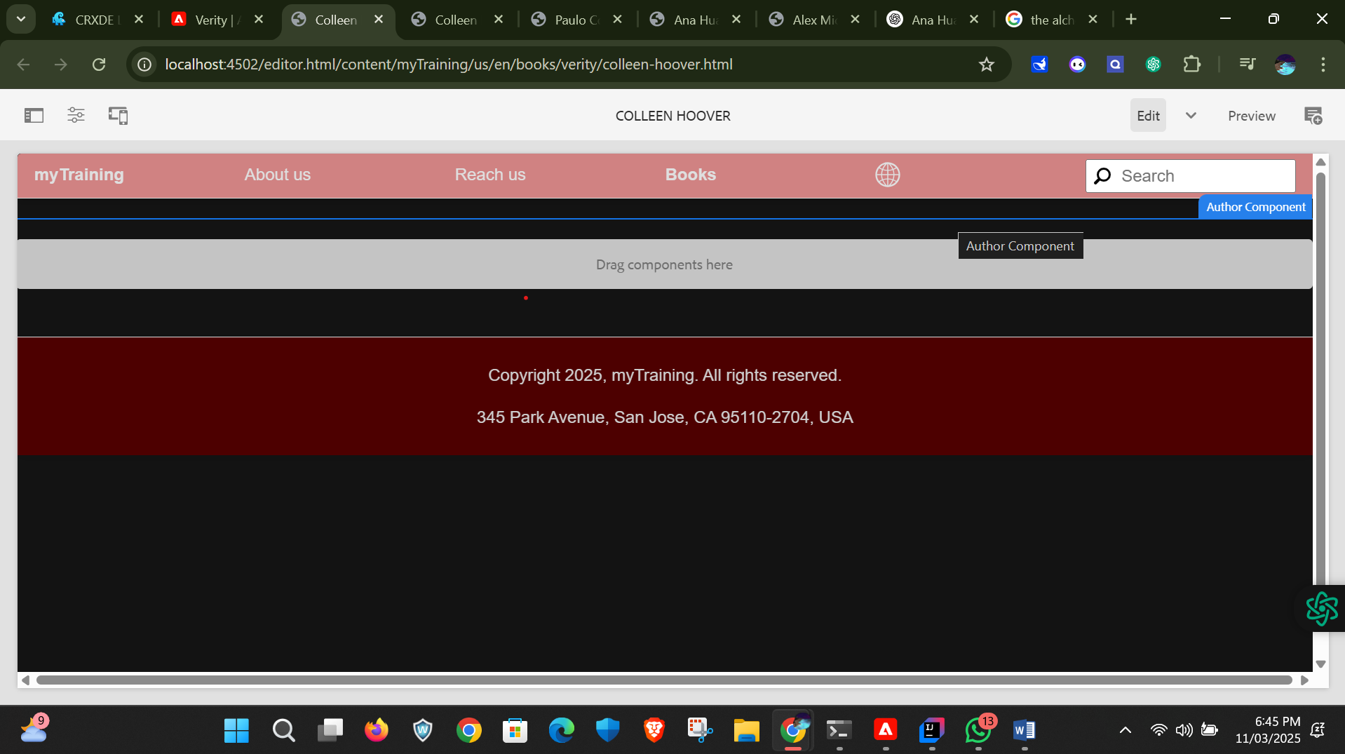

After that we need to provide content in dialog box and filling up the dialog box click on done.

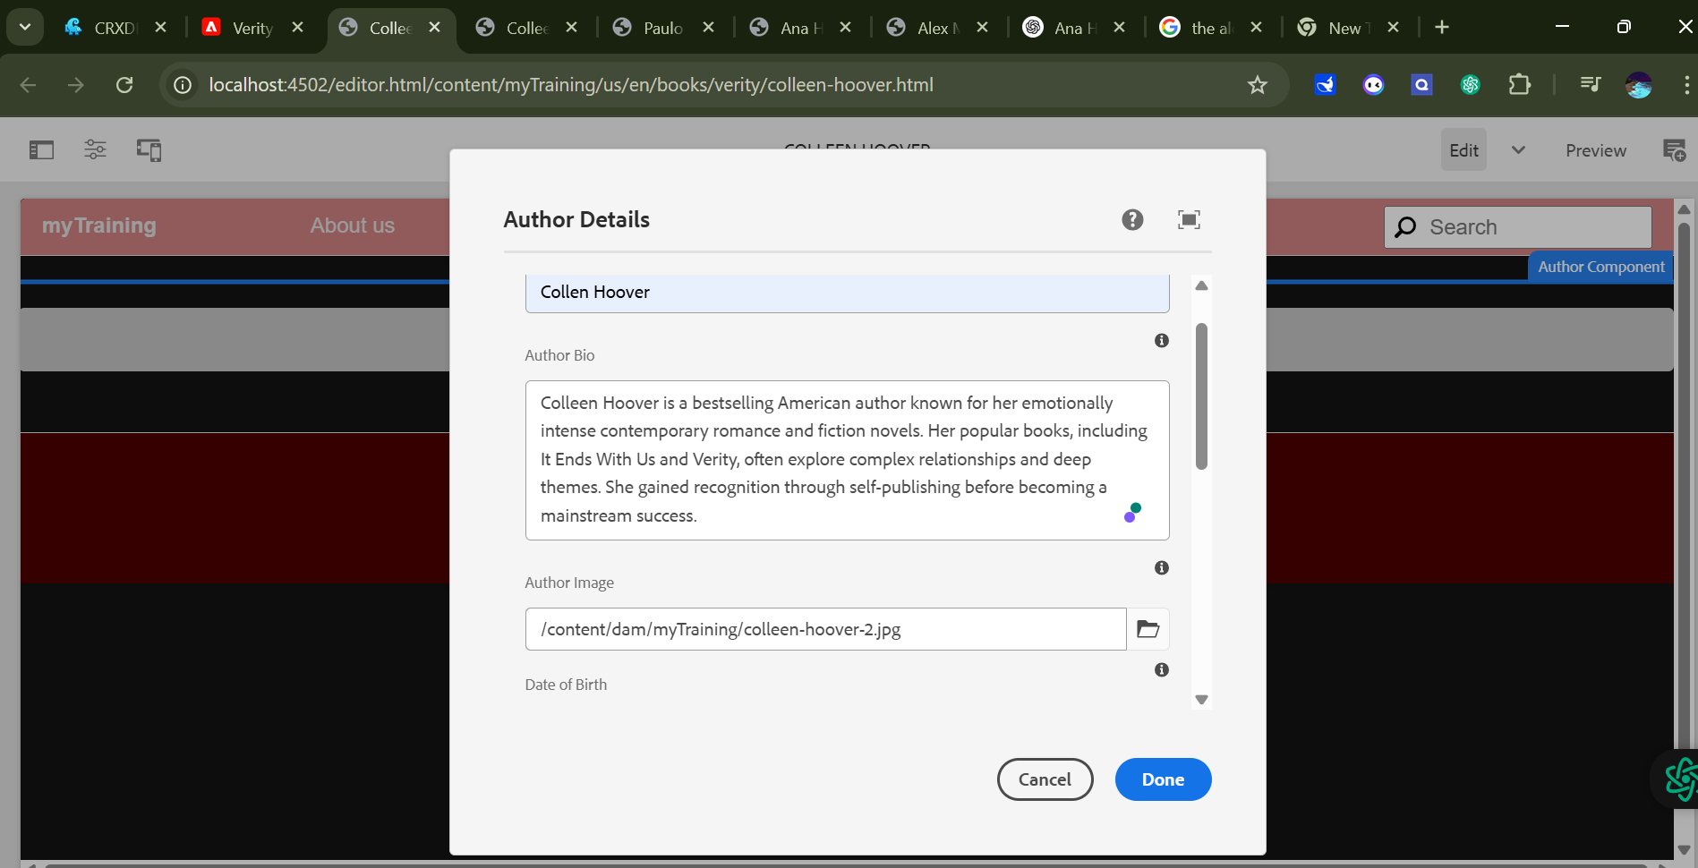

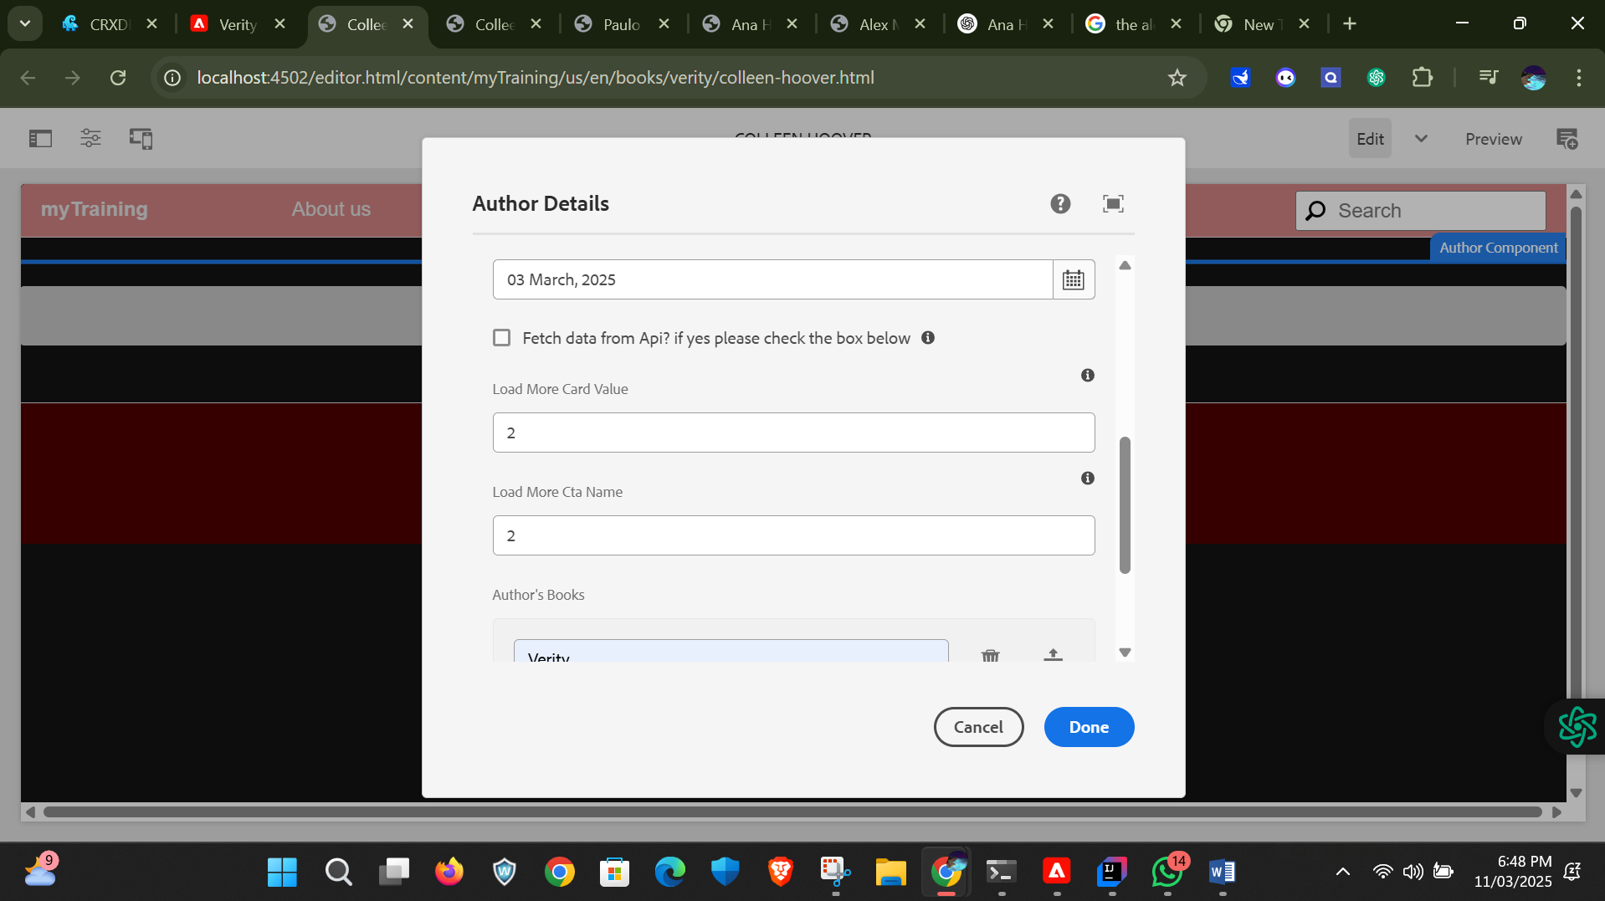

Now that author page is created we need to provide connection to the book page with the respective author here I provided the example of how the connections work

When we click on the author name it will navigate to the author detail page

